Federal State Budgetary Educational Institution of Higher Education «Kazan National Research Technical University named after A.N. Tupolev–KAI»

### German-Russian Institute of Advanced Technologies

### Research in Computer and Systems Engineering

INSTRUCTIONS

to the practical work No. 2

by discipline "Basics of Neural Networks "

" Multilayer Perceptrons. Deep learning Computation"

### Kazan - 2020

**PRACTICAL WORK No. 2**

**Name of practical work**

Multilayer Perceptrons. Deep learning Computation.

**The goal of practical work**

To get understanding of multilayer perceptron network’s architecture and practical skills of training high-capacity models.

**TASK FOR PRACTICAL WORK**

1. Run a jupyter notebook file. *If you don’t remember how to do it, refer to Lab 1 document,* *paragraph 4.*
2. Start with *mlp.ipynb* file.

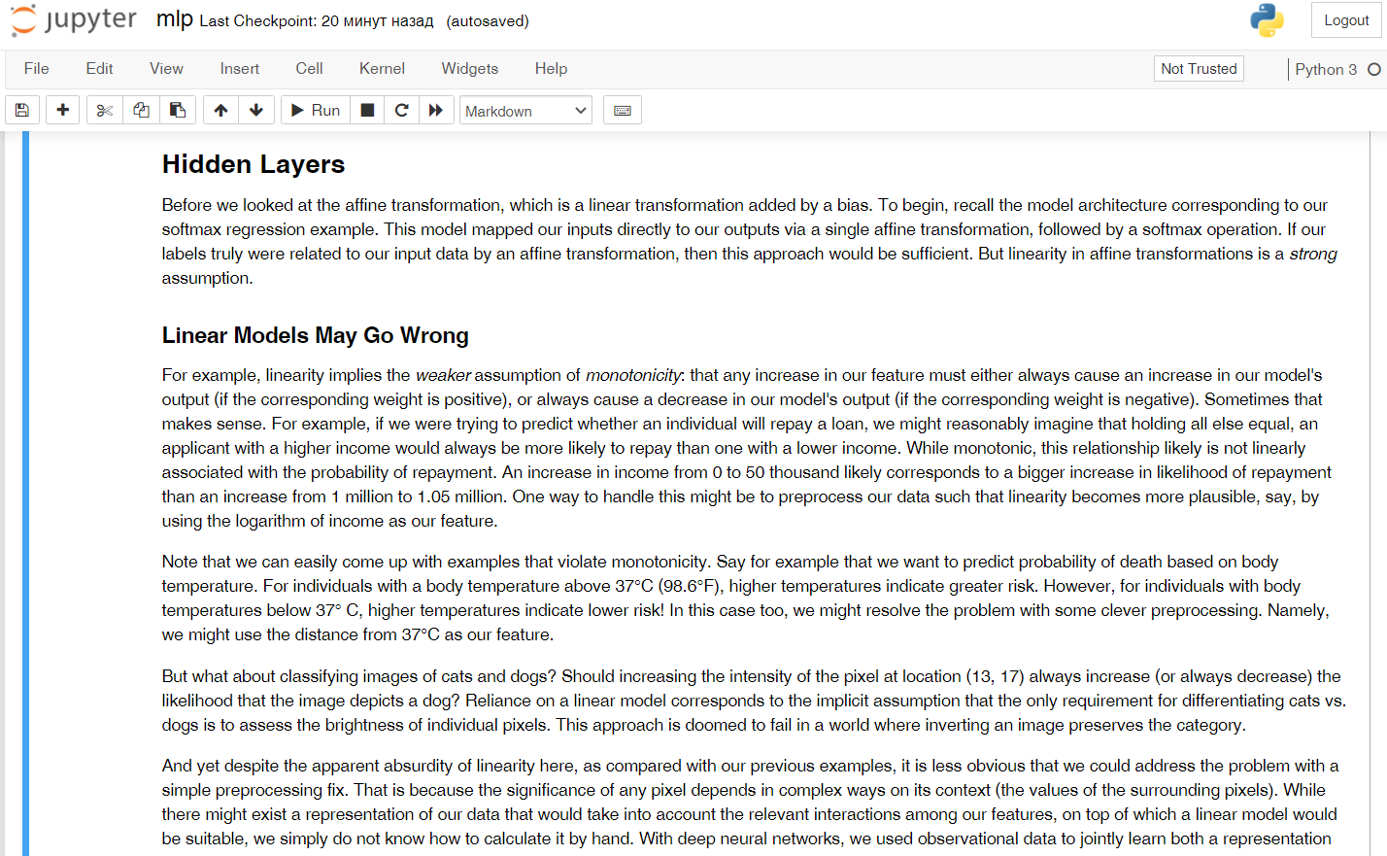

Fig. 1. Jupyter notebook with opened *mlp.ipynb*

Jupyter notebook consists of a sequence of cells. A cell is a multi-line text entry field, and you can execute its contents by clicking the Run button ( ) on the toolbar. Code cells can be run in any order you want. If the code takes too long to execute and you want to interrupt it, you can click the Stop button.

Further, to work with the code in this work, it is necessary to sequentially launch *every* block (even with text data only) using Run.

2. Sequentially Run the files in folder *multilayer-perceptrons* and after that in folder *deep-learning-computation.*

**PRACTICE REPORT**

**Name of practical work**

Multilayer Perceptrons. Deep learning Computation.

**The goal of practical work**

To get understanding of multilayer perceptron network’s architecture and practical skills of training high-capacity models.

**Done by**

Group № ______

Student’s Name, Last name ______________________________________________

**The report is received in the form of an executable file for Jupyter Notebook or link to the Google Colab**

**Task:**

1) Setup the environment and run all the notebooks

2) On previously found dataset create multilayer perceptron network for prediction the value by using high-level APIs and perform the following tasks:

1. Compare different activations functions (ReLu, Sigmoid, etc.). See how change the result and try to analyse it.
2. Try to change size of training/validation data. Plot how change the result of loss function. Analyse from under/overfitting problems.
3. Use $L_{1 } and L_{2 }$ regularization. Analyse the changing of the result.
4. Perform the dropout method. Analyse the result.
5. Perform the Xavier initialization.